Time to make your own exponent clock!

Before we get started, let’s review a few key concepts:

Exponents:

This refers to taking a number to a “power.” This is just a fancy way of saying multiply the base number by itself as many times as the exponent (power) tells you too.
Power

$X^{2}$
Base
Looking at an example:
$$3^{2}=3*3=9$$
$$3^{3}=3*3*3=27$$

Square Roots:

This refers to the symbol . The number underneed the house with a little check mark is refered to as a “radical.” So, $\sqrt{3}$reads “radical 3.” Every real number has a number that when multiplied by itself equals that orginal number. Think about the number 9. What number multiplied by itself equals 9? 3. This means that $\sqrt{9}=3$. What about 16? $\sqrt{16}=4$. We would read this as “radical 16 equals 4” or “4 is the square root of 16.” Numbers like $\sqrt{3}=1.73…..$ are repeating forever and are called what?

Now for the math clock!

To make your clock you are going to solve the collection of expressions below (or come up with your own expressions). There are more expressions than you need for the clock, so some will total to numbers that don’t go on a typical clock. Once you solve, you will place the expression in the appropriate place on the clock on the next page. The math theme is the number 9.

$$\frac{99}{9} 9+\frac{9}{9} 9-\frac{9}{9} \sqrt{9}+9-9 \sqrt{9}+\frac{9}{9}$$

$$\frac{9}{99} \frac{9+9}{9} \sqrt{9}×\sqrt{9} 9^{2}÷\left(9×9\right) \frac{9+9}{9}+ \sqrt{9}$$

$$\sqrt{9}+\sqrt{9} 9^{3}- \sqrt{9} 9+\frac{\sqrt{9}}{9} \sqrt{9}+\frac{9}{9}+\sqrt{9}$$
______________________________________________________

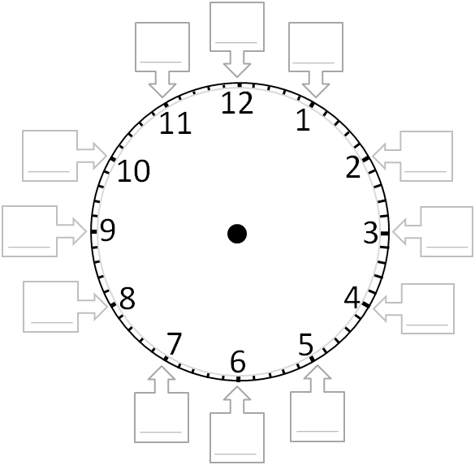
Using any materials, create a 3-D or digital version of your exponent clock.

